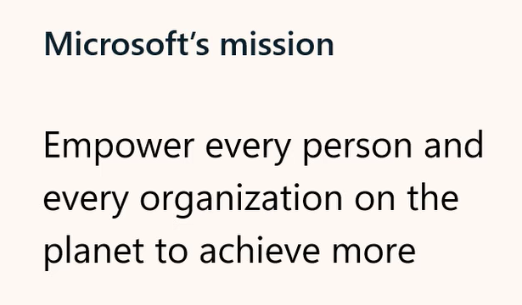

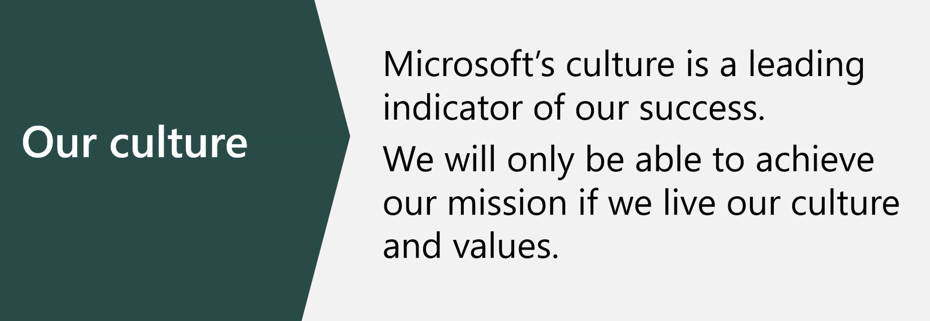

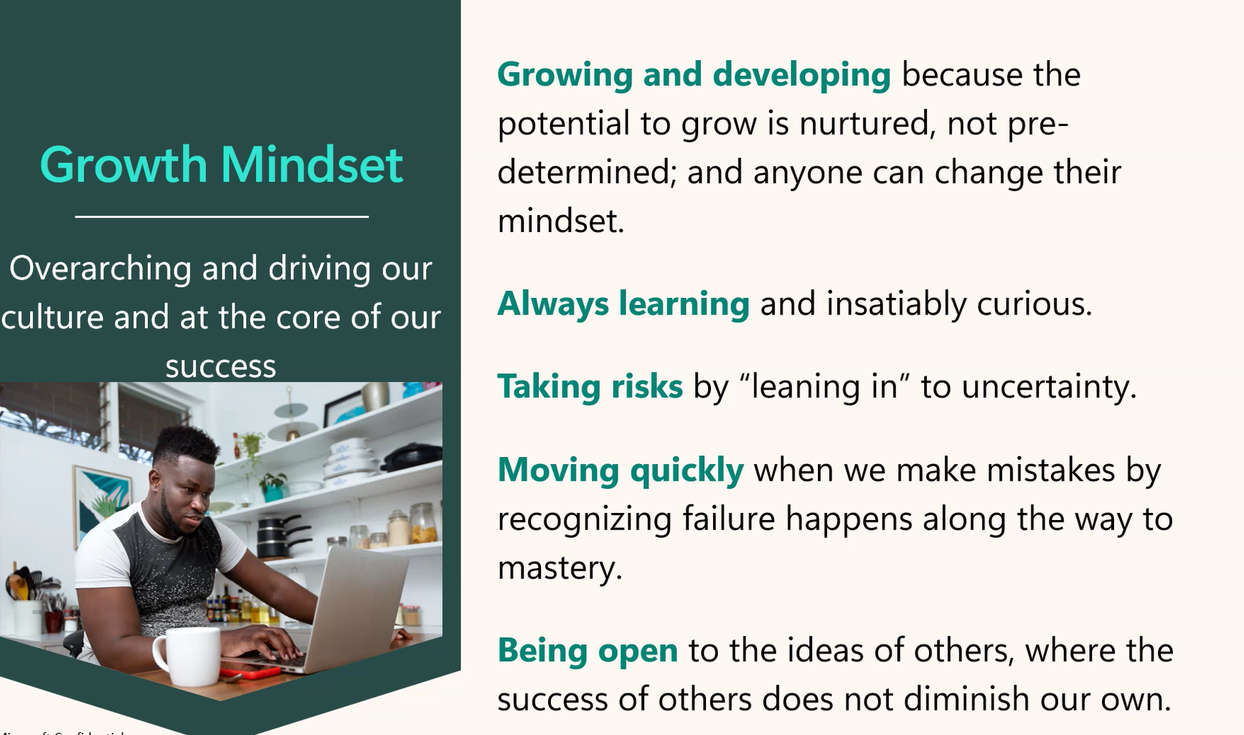

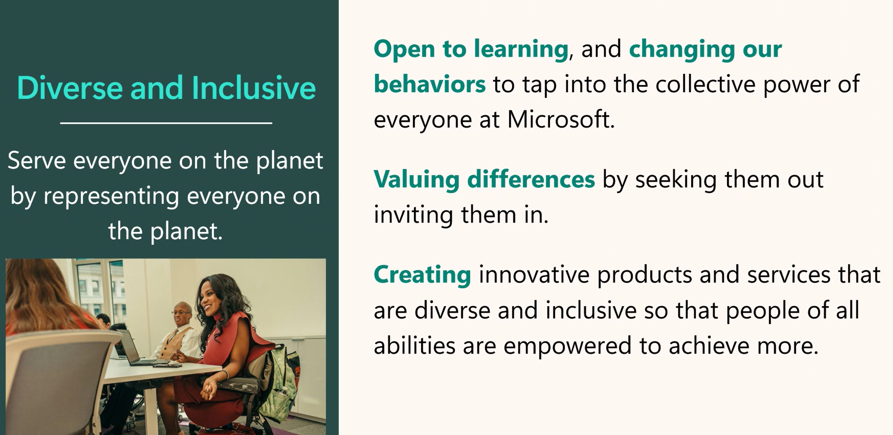

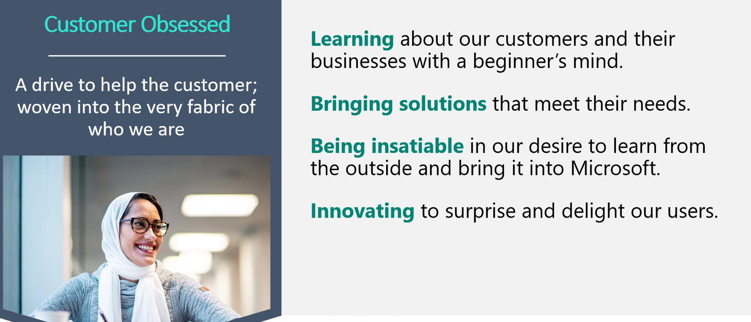

Expand the definition of customer to include others you work with

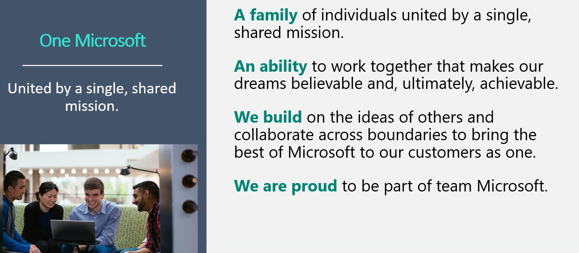

Theme in interview: Describe when you worked on a cross-functional team

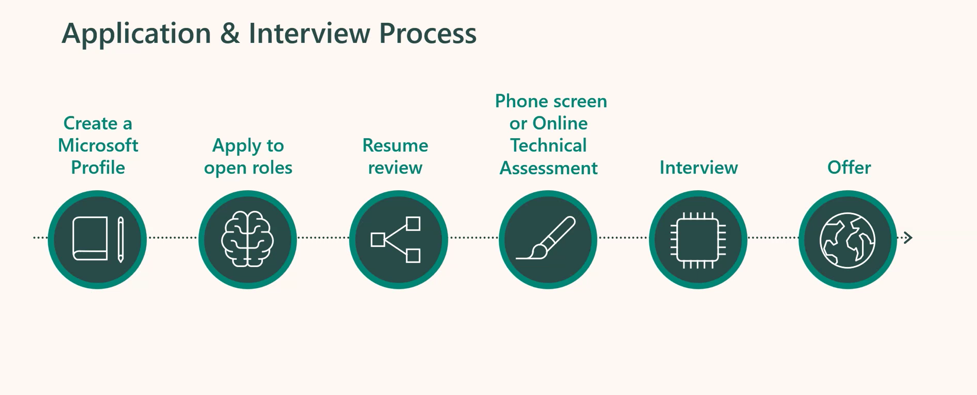

90 days required to not pass an assessment for early in profession. Experieinced can continue to reapply without a waiting period.

Results usually 2 weeks after last round.

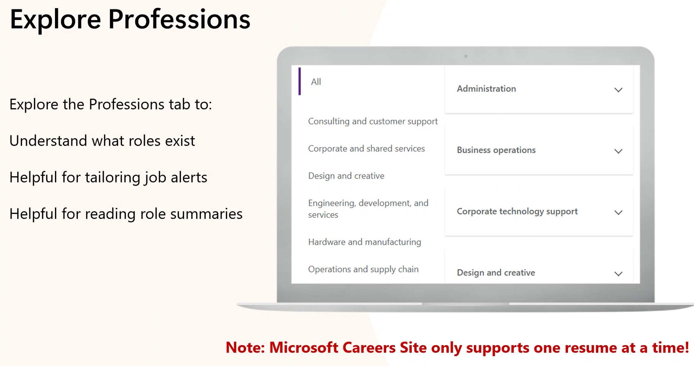

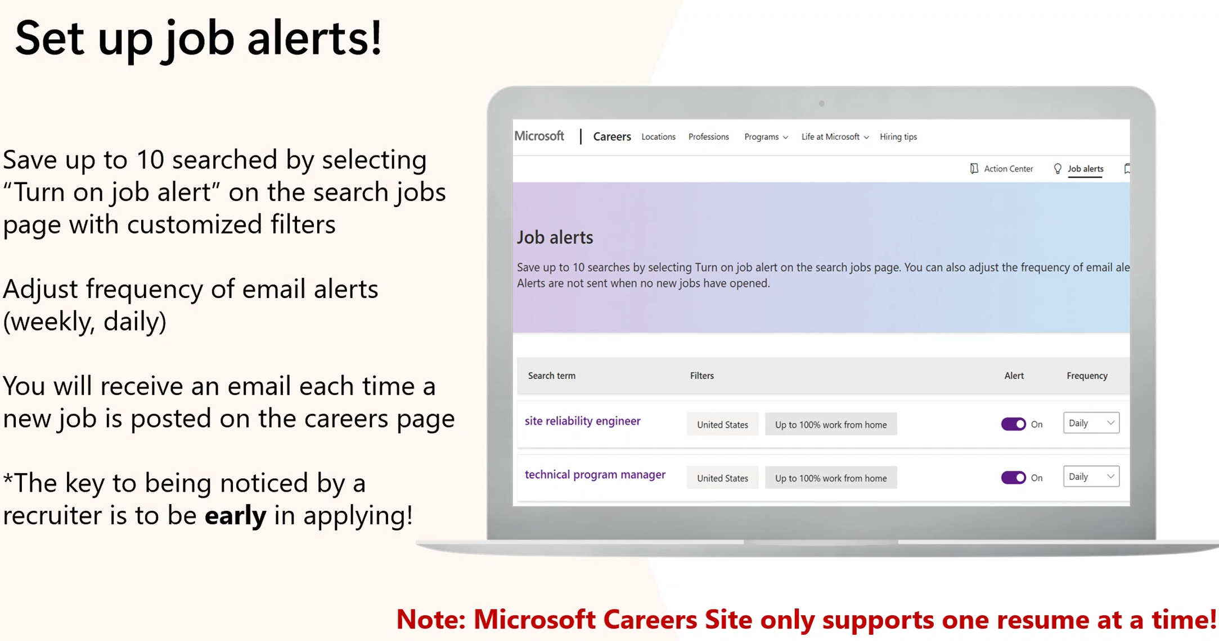

Set up job alerts and apply EARLY!! That means you need to check daily if not more.

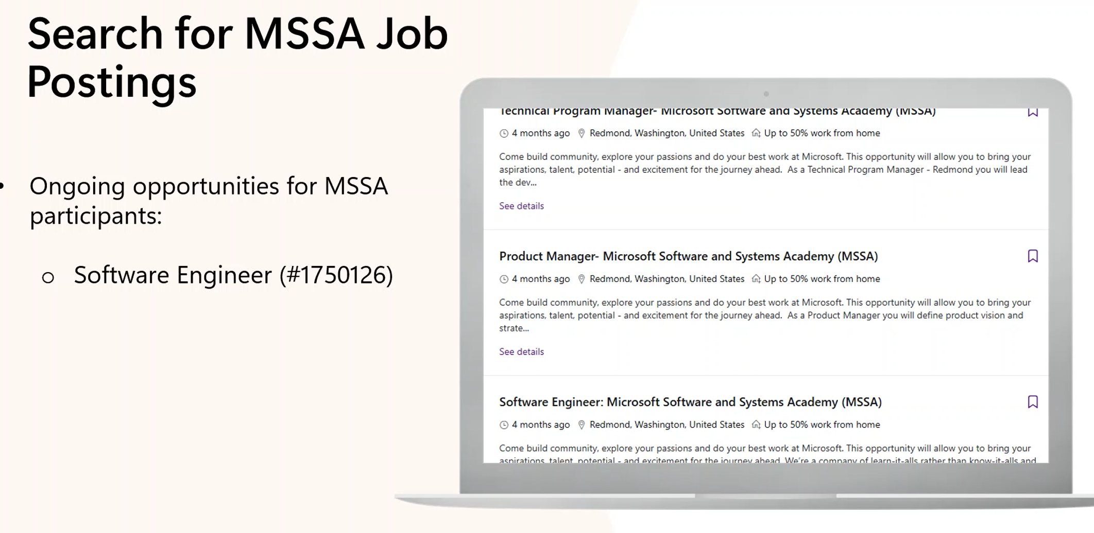

Posted several months ago, keeps

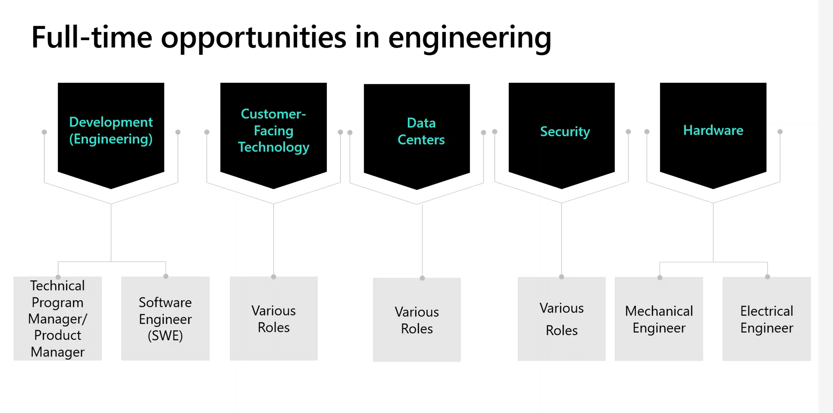

Lots of data center and security roles. Business functions as well

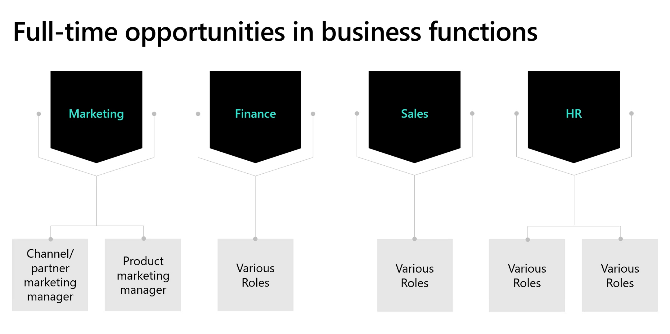

Interview prep

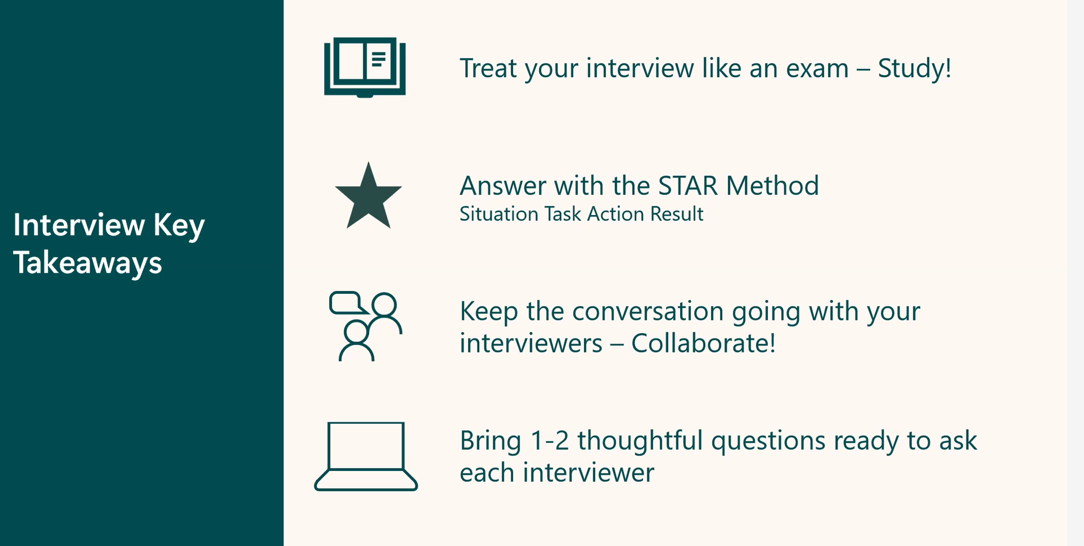

How many more times are you going to hear about the STAR method! Make sure to include metrics in the resume and in the discussion. “R” Reflections or in our case “T” for Tie-in.

Thinking out loud – will help your interviewer understand how you are thinking. Narrating your approach. Ask questions along the way. Wear a “learn-it-all” hat

Get away from generic: What would a day to day better; what would MY day to day look like?

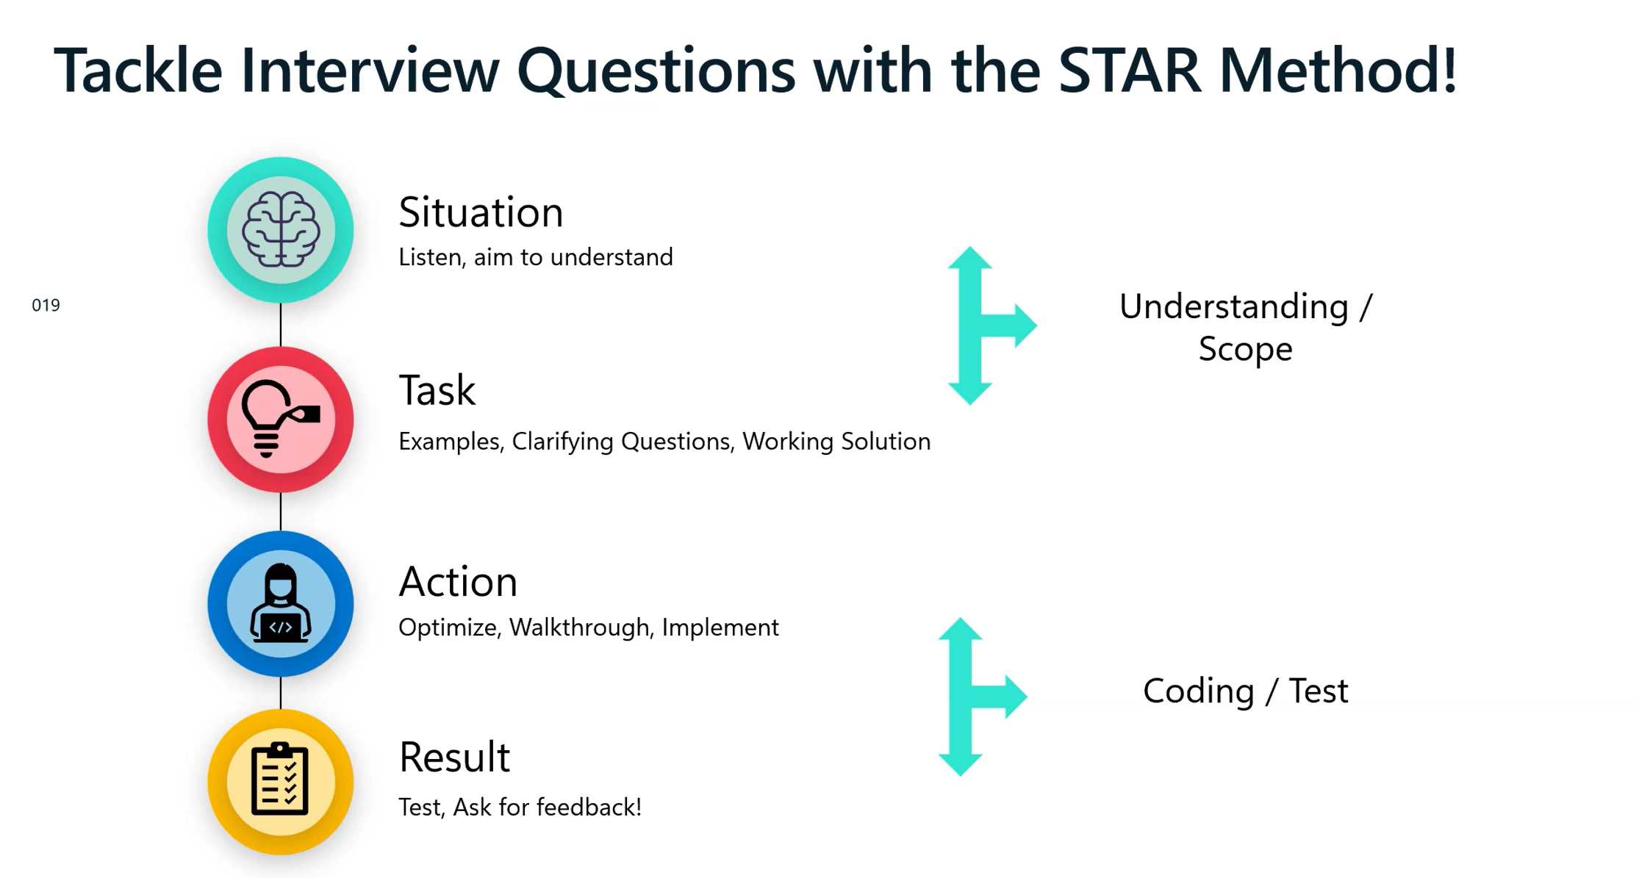

Good for behavioral or technical question

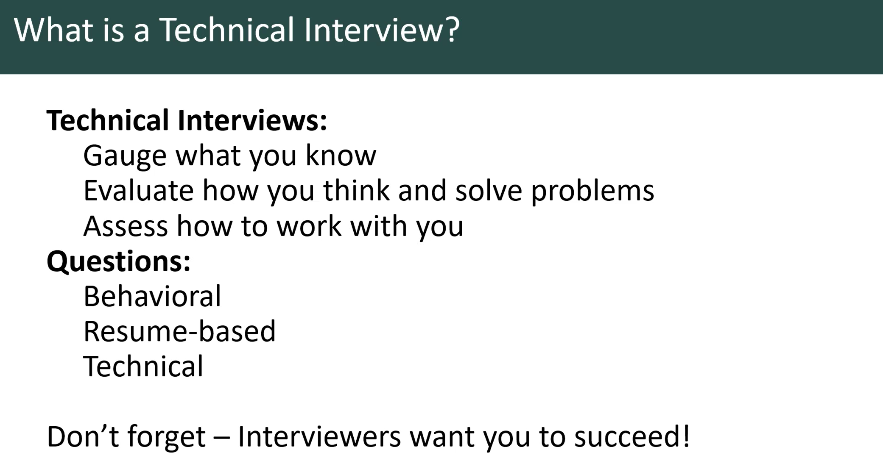

How you think and how do you function in a team environment.

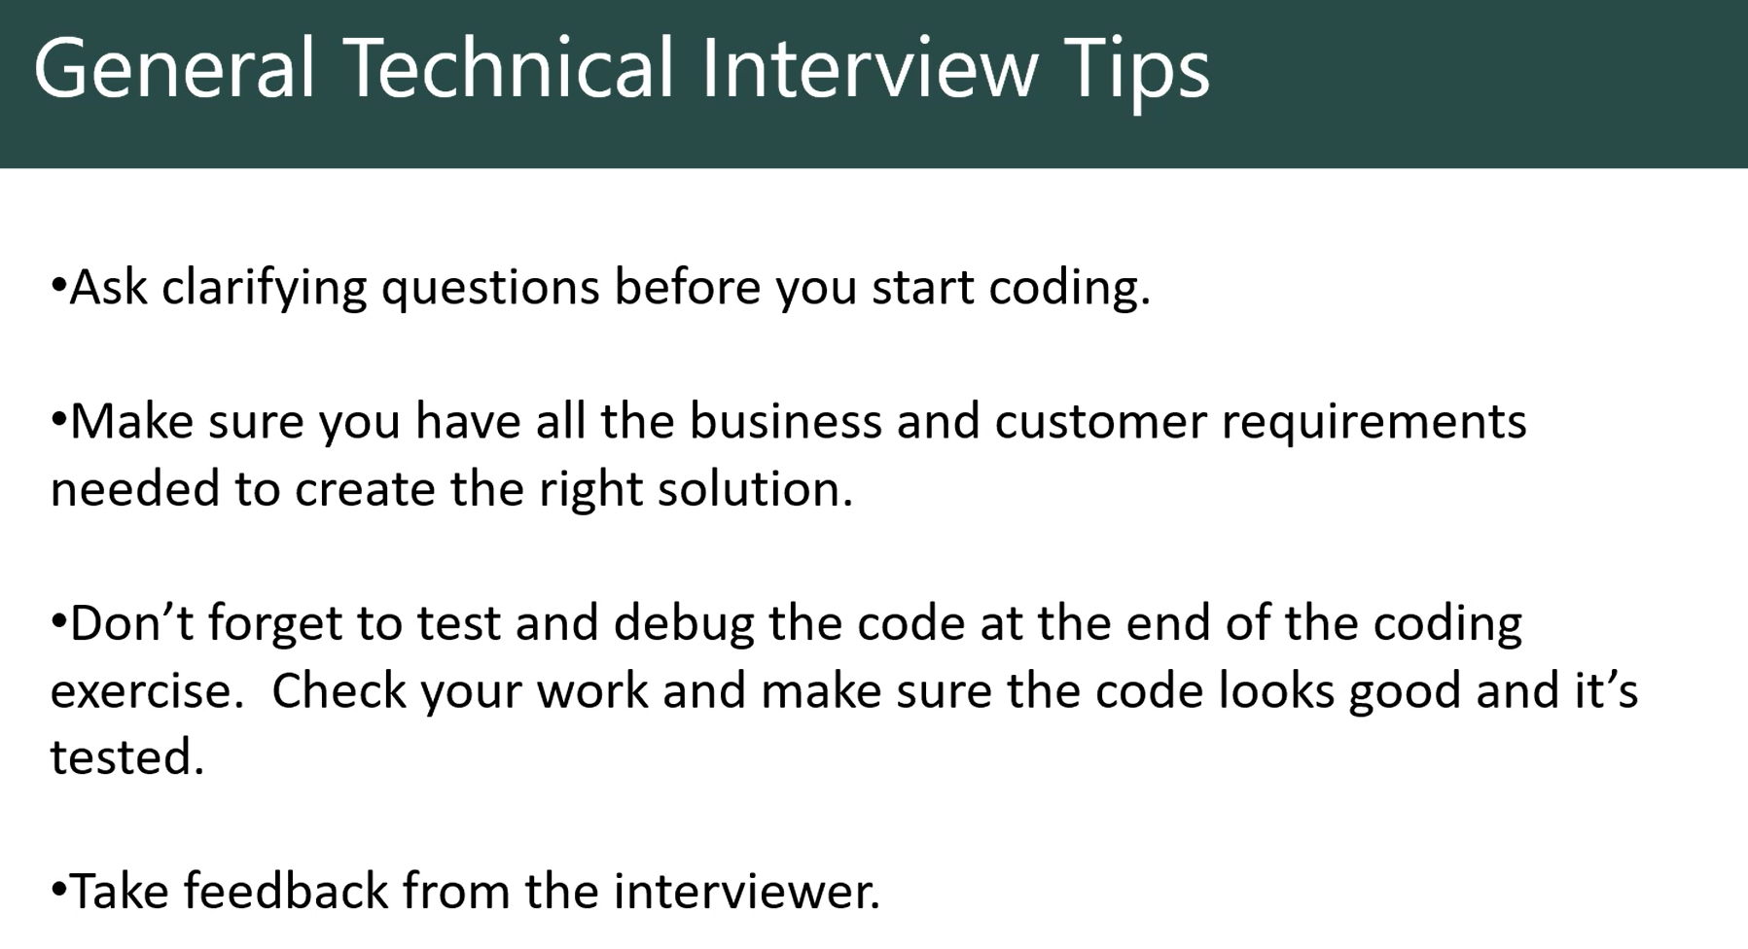

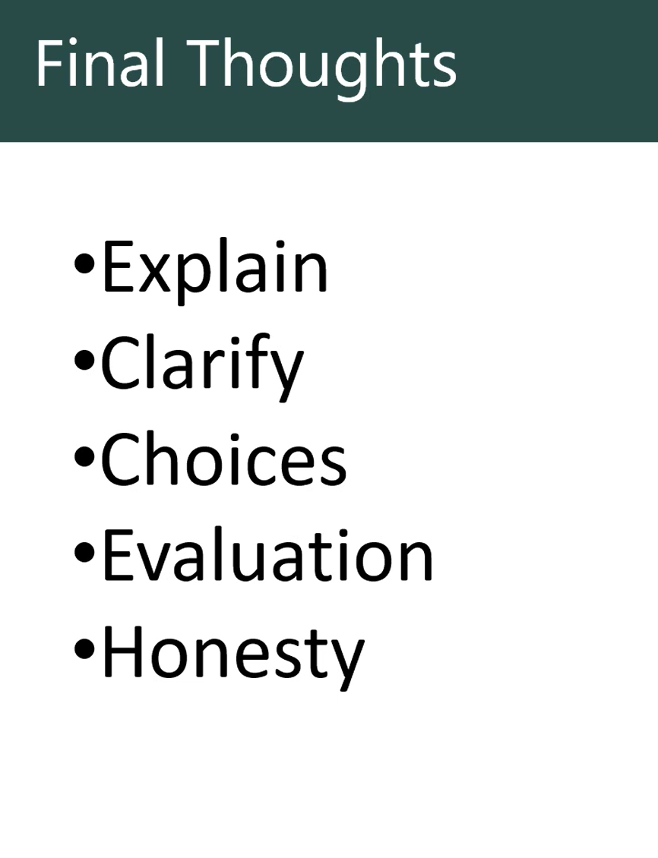

Practice explaining your thought process to help

Clarify – Sometimes interviewers ask questions to help you get started in the thinking process

Choice – Can you ID the pros and cons of solutions and develop plans to mitigate

Solutions: Do they work and why they might not work. Are the test cases you can use to see if your code works as intended

Be transparent!

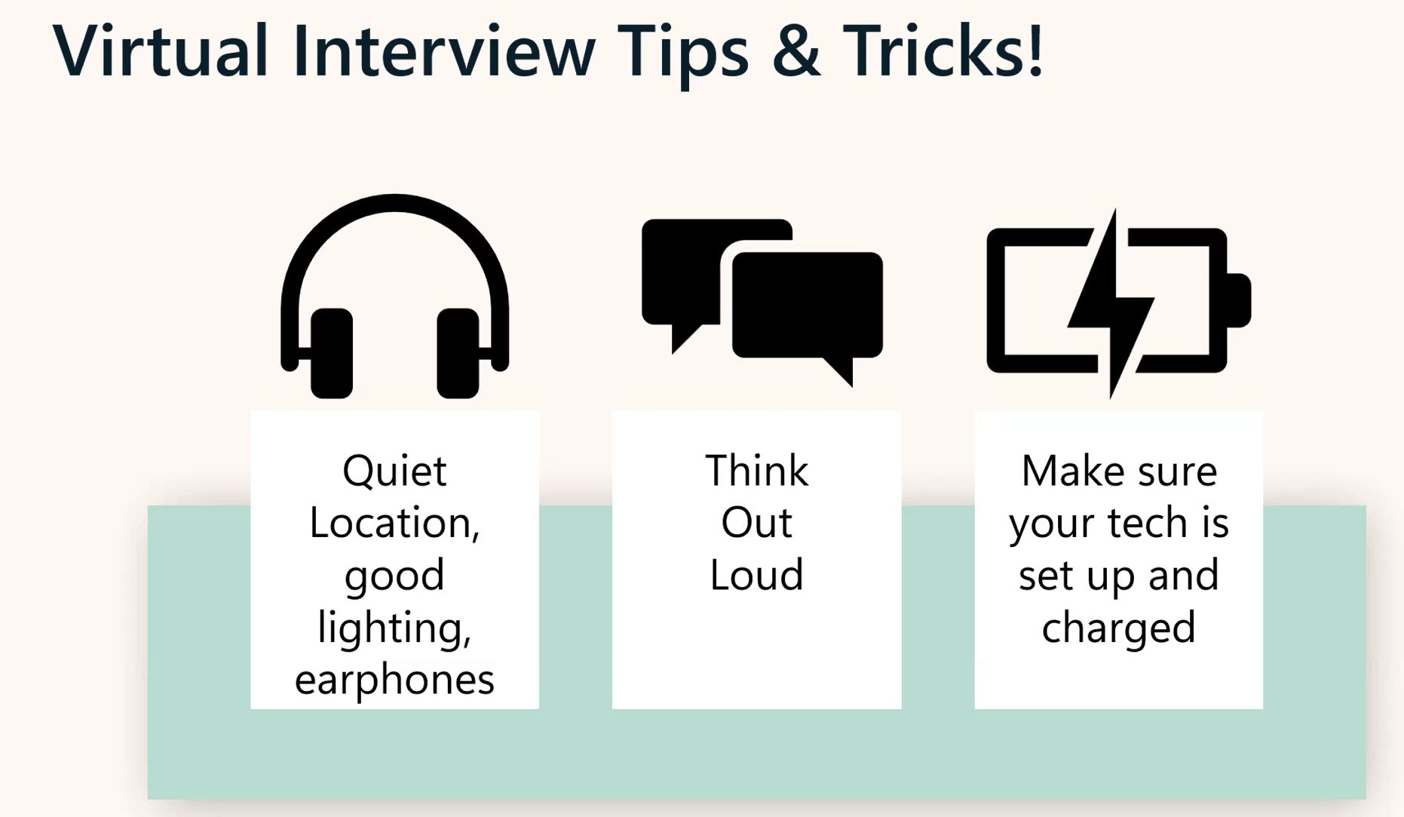

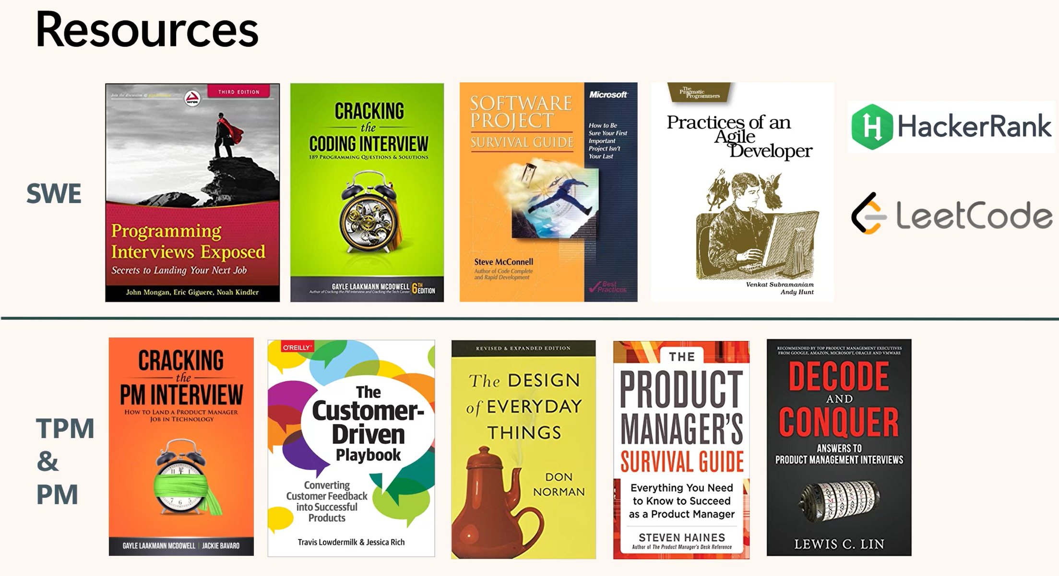

Phong Mai and Maggie Sullivan

How can MSSA participants distinguish themselves in a large candidate pool.

Phong applied 3 times from interested to committed! Did some extra research, mission culture, tailor the resume to the job description. Looking for keywords as a search query. Showcase your transferable skills - what are transferable skills from the military to the role (EIP). Practice answering behavioral questions with someone else. Thoughtful questions pertaining to the position.

Maggie: What advice would you give to an aspiring applicant (MSSA). Thinking about mindset and how much it matters. The veteran experience is challenging to going from a culture to a culture (Stained glass analogy). You have a lot to offer that civilian candidates cannot bring. What is helpful is Microsoft’s core competencies: adaptability, collaboration customer focus, and drive for results. Try and find stories that bring out those skills. Learning something on the job. Passion to support a mission! The military has that. Drive to support a mission. Push yourself to be comfortable talking about yourself. I versus we. Try and understand the connective tissues from what you’ve done and how it connects to the civilian world. Core competencies are on the Microsoft careers site. [Interview tips | Microsoft Careers](https://careers.microsoft.com/v2/global/en/hiring-tips/interview-tips.html)

Phong: Understand the “Why” at the beginning. The company, the mission, the job, the culture.

Maggie: Advice to highlight transferable skills? In general, make your resume is easy to consume. Make it easy to read. It’s not really about any one questions but can I work with this person?

Phong and Maggie: What are successful way to frame a career transition?

Phong: As a sales guy, my intention was to do recruiting. Reviewed an organizational chart and pinged them and asked for advice. Know your worth and know your storey. Good to have a story and data to back it up.

Maggie:

⁠Kelsey Saboori  If there's time:  Where on a resume is your favorite place to find keywords - professional summary, qualifications, or throughout?

Top piece of advice: Maggie: Resiliency! Don’t take thing personal just keep applying.

Phong: Preparation! Preparation breeds confidence. Being authentic shows.